**IBM IoT Assignment – 2**

1. **Build a python code, assume u get temperature and humidity values (generated with random function to a variable) and write a condition to continuously detect alarm in case of high temperature.**

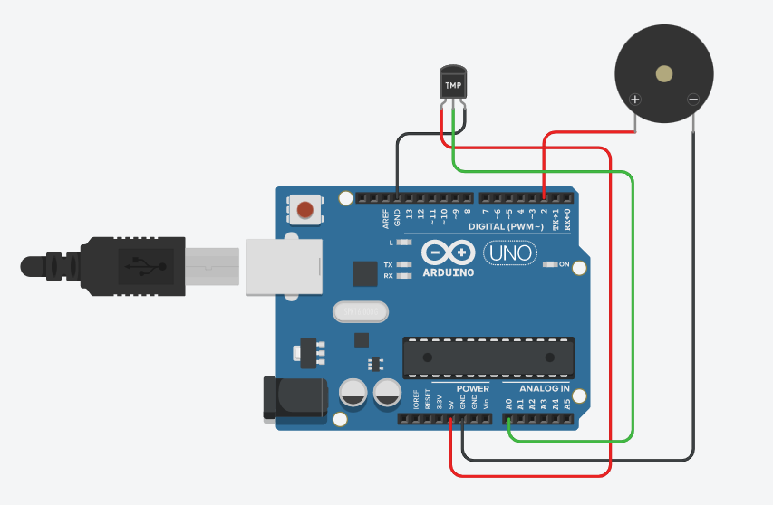

**Python code:**

import random

while(True):

a=random.randint(10,89)

b=random.randint(10,89)

if (a>20 and b>60):

print("high temprature and humidity of: ",a,b,"%","alarm is on")

elif (a<35 and b<60):

print("Normal temprature and humidity of: ",a,b,"%", "alarm is off")

break

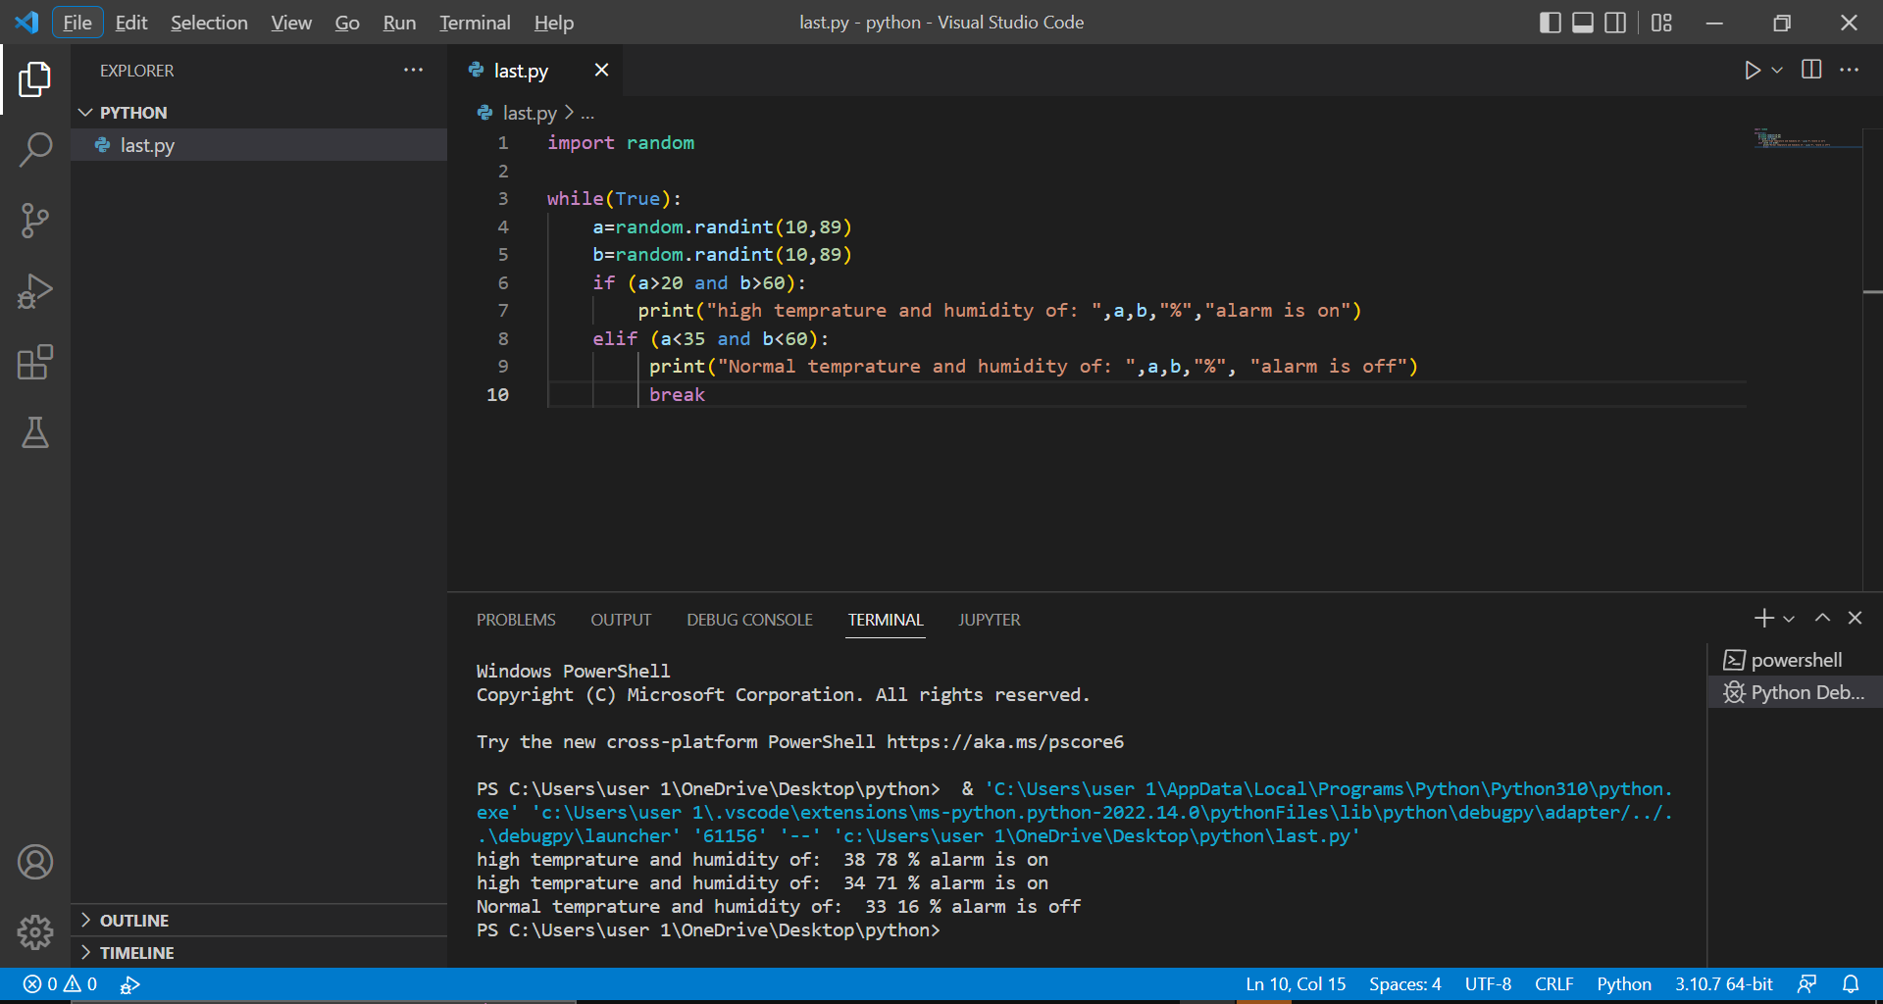

**Arduino Code:**

/*

Temperature and Humidity Sensor with an Alarm

*/

void setup()

{

pinMode(2,OUTPUT);

Serial.begin(9600);

}

void loop()

{

unsigned int value=analogRead(A0);

Serial.println(value);

float voltage=value*5000.0/1023.0; //converts A0 reading to mV

Serial.println(voltage);

if(voltage>500) //only measures form 0 deg. C and higher

{

unsigned int temperature=(voltage-500.0);

Serial.println(temperature);

if(temperature>35) //temperature > 35, beep buzzer once

{

digitalWrite(2,HIGH);

delay(100);

digitalWrite(2,LOW);

delay(100);

}

}

else

{

Serial.println("below 0 deg Celcius");

}

delay(2000);

}

**Link:**

<https://www.tinkercad.com/things/ccTWw2cUsHO-copy-of-temperature-and-humidity-sensor/editel?sharecode=L-y6SXNFFRC0PDzjdB2mezcv8DMSo5hmFdqr5Z6u1Tg>